**ADB interface driver**

**Version 1.0**

**Version History**

|  |  |  |  |
| --- | --- | --- | --- |
| **Version** | **Date** | **Handled by** | **Comments** |
| V1.0 | 27-May-2019 | ZL Chen | First version release. |
| V1.1 | 06-June-2019 | ZL Chen | Join the Block Diagram. |

Precondition Setting:

N/A

Please follow the implement as below:

Block Diagram:

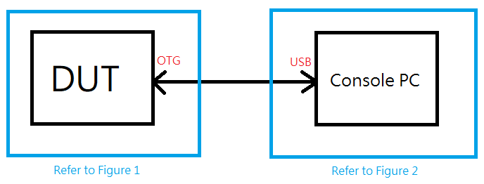

Step 1:

Please insert the micro USB to any computer and DUT (Android System).

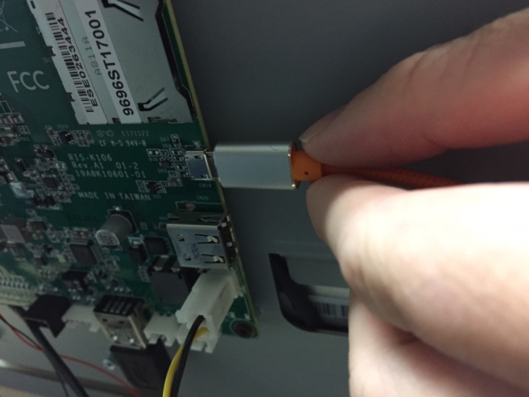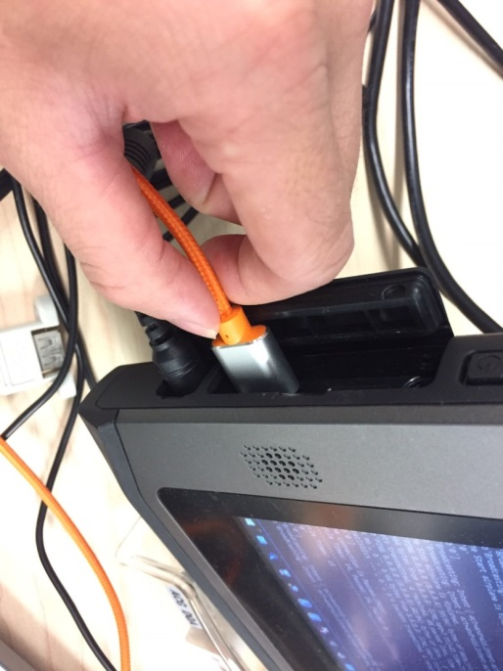

Figure 1 Figure 2

Step 2:

Install the ADB Interface driver by USB driver under the device manager. (Figure 2)

The USB driver is under the installer folder. (\automation\installer\usb_driver) 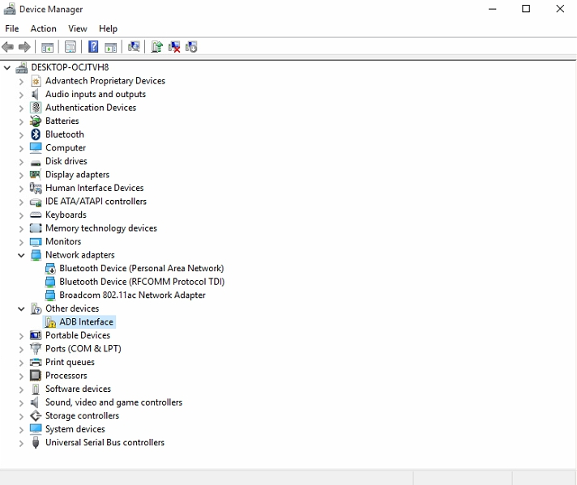

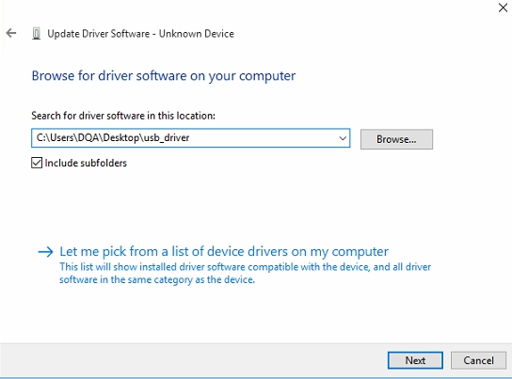

Step 3:

Open the “Developer options” in the Setting button and launch “USB debugging”. (Figure 1)